Service Learning Lesson Plan

Title: Creating art with Zentangles Group/Date: Cooper House, March 7, 2016

Lesson Idea and Relevance: What are you going to teach and why is this lesson of importance to your students? How is it relevant to students of this age and background? | - How to use drawing techniques to create repetition and pattern in their designs  - Many students enjoy simple mark making and repeating shapes. Zentangles will help them combine or expand these acts into a piece of art.

Essential Understanding (s): What are the “big ideas”? What specific understandings about them are desired? | Essential Question (s): What provocative questions will foster inquiry, understanding, and transfer of learning?
- Artists can use the expressive features and characteristics of art to create art. | - Why would an artist draw the same shape more than once?  - How can an artist fill space using repetition?  - Use a “quick field trip” to find repeated shapes that create pattern in the environment. (Outside? In the room?)

Outcomes - Students will be able to...What key knowledge and skills will students acquire as a result of this unit? ...Art history and culture; expressive features and characteristics of art; art materials, tools, and techniques? What should they eventually be able to do as a result of such knowledge and skill? ...Compare and contrast art work; analyze sketches?
Students will be able to
- Students will be able to recognize pattern and repetition in the real world
- Students will be able to explain what repetition and pattern are and how they can be used in art.
- Students will be able to draw with line, shape, and value to create repetition or pattern.
- Students will be able to create a composition using repetition or pattern.
- Students will be able to analyze their work and explain the use of repetition or pattern in their design.

Student Reflective Activity: Through what authentic performance task(s) will students demonstrate the desired understandings? How will students reflect upon and self-assess their learning? | Assessment Instrument (s): By what criteria will “performances of understanding” be judged?
“Artist Talk”  Students will discuss their works, and explain their process. They will explain what patterns they used first, and how they chose to go about their overall composition in order to convey an idea. | - Exceeds expectations: Students create zentangles, using a variety of patterns to create an image of their own invention  - Meets expectations: Students use at least 2 patterns to fill in a printed zentangle  - Developing: Students practice drawing patterns, but don’t fill them into an image.

Pre-assessment: How will you help the students know where the unit is going and what is expected? Help the teacher know where the students are coming from (prior knowledge, interests)?

- Have you ever heard of Zentangles?
- What is the general definition of repetition when it comes to art?
- How can an artist use repetition and pattern in their work?
- What patterns interest you to try?

Motivation: How will you hook all students and hold their interest? | Ideation: How will you equip students, help them experience the key ideas, and explore the issues to generate ideas for their art work?
Demonstrate simple pattern ideas and allow them to try a few on their own. Students will sit at the tables in the front and see a demonstration of what Zentangles are on the whiteboard. They then will get to try up to 10 different patterns: Cross hatching, stippling, bubbles, wave, triangles and 5 patterns of their choice. | Students will get to test out a few basic patterns as well as a few that interest them.  Discuss how pattern and repetition can help an artist fill space and convey an idea.  Examples will be displayed on the board so students can see how to fill space through pattern.

Procedures: How is the lesson organized to maximize initial and sustained engagement as well as effective learning? Provide opportunities to rethink and revise their understandings and work? Allow students to evaluate their work and its implications? Include literacy and numeracy?
- Greet students, talk to them, intro activity (15 minutes)
- Introduce and briefly demo zentangles (20 minutes)
  - Show students how to draw a zentangle (on paper and with clay)
    - Show examples of patterns they can draw (triangles, lines, circles)
    - Demonstrate how the patterns can be placed into different shapes to make an image
    - Show students how they can draw into slabs of clay to make an image
  - Show examples of zentangles 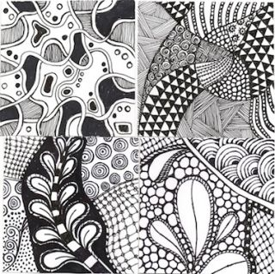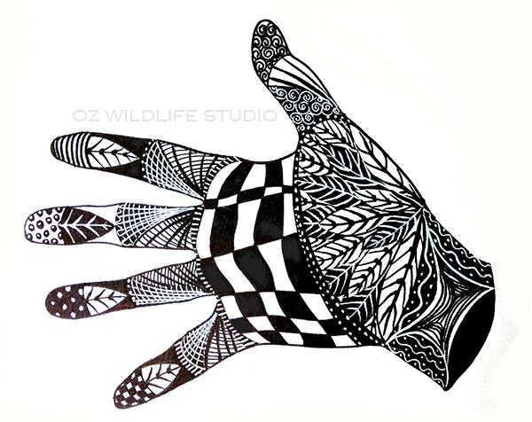
  - Let them play with and explore zentangles
  - Show students more techniques on an individual basis:
    - more complex patterns
    - zentangles in different shapes
    - rolling coils of clay to create lines
    - cutting out shapes
- Regroup to talk about their work (10 minutes)
  - Ask students which processes and techniques they prefer and why
    - ex:What did you do to make that pattern? What does is look like? Which did you like using the most? How could you use the patterns to make something new?
  - Discuss how they used the clay
    - How did your design change when you used clay? How did you make lines with the clay?
- Prompt students to create an object from the shapes they have made (25 minutes)
  - Work with individuals to identify what they want to create or what their image is looking like
  - Let the shapes they were playing with direct what they make
  - Show examples of landscapes, buildings or figures that fit with what they choose to make
  - Share student’s work and discoveries with the group as they arise
- Regroup to discuss and share everyones’ art (15 minutes)
- Clean up (5 minutes)

Materials and Resources: What is needed to complete the learning plan? List materials and resources in a bulleted format.

- Paper
- Markers
- Pens
- Colored pencils
- Clay
- Aprons
- Gloves
- Rolling pins
- Clay tools
- Examples of zentangles

Preparation and Safety: What do you need to prepare for this experience? What safety issues need to be addressed? List steps of preparation and safety in a bulleted format.

- Set up materials beforehand
- Don’t assign seats-ask students to sit at the table with the medium of their choice (2 tables set up)
- Leave stools on back tables up
- Ask aides if they have any safety concerns

Accommodations: How is the lesson tailored (personalized) to the different needs, interests, and abilities of learners? ...Access (Resources and/or Process) and Expression (Products and/or Performance)?

- Clay zentangle station so that Abby can feel what she’s doing and other students have two options to explore
- Demonstrate and explain the process slowly to make sure everyone understands
- Maintain a relaxed environment- encourage students to play

